Math 3 Unit 6 Study Guide Unit 6

**Directions:** Find the value of each variable. Then find the measure of each labeled angle.

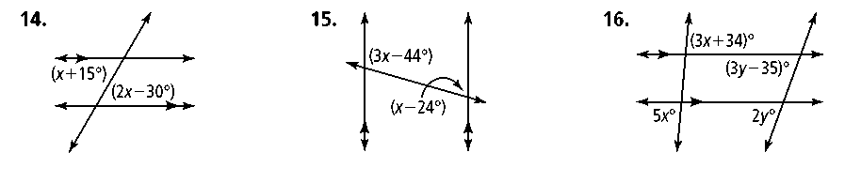1. 2. 3. 

**Directions:** Name two triangles that are congruent by ASA.

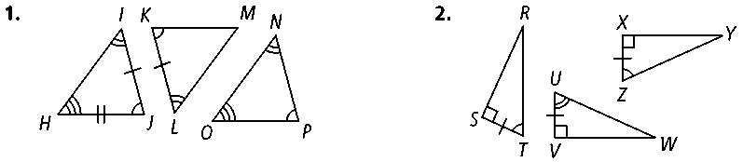4. 5.

**Directions:** Would you use SSS or SAS to prove these triangles congruent? If there is not enough information to prove the triangles congruent by SSS or SAS, write *not enough information.* Explain your answer.

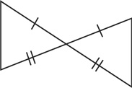

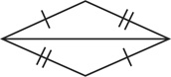6. 7.

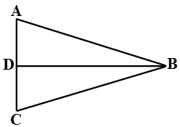 8. Given:  is the perpendicular bisector of   Prove: ∆*BAD* ≅ ∆*BCD*

|  |  |
| --- | --- |
| **Statements** | **Reasons** |
| 1) is the perpendicular bisector of *.* | 1) Given |
| 2) | 2) Definition of segment bisector |
| 3) ∠*ADB* and ∠*CDB* are right . | 3) Definition of perpendicular |
| 4) | 4) |
| 5) | 5) |
| 6) | 6) |

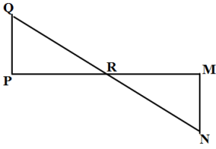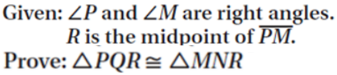9

**Directions:** Find the values of the variables in each parallelogram (14 is a trapezoid)..

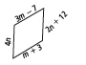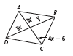

10. 11.

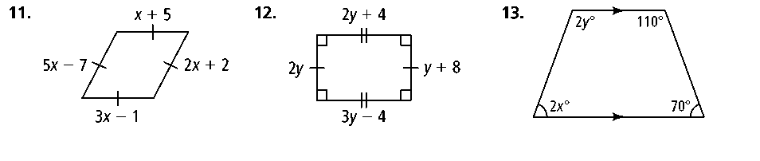12. 13. 14.

**Directions:** The polygons are similar. Find the value of each variable.

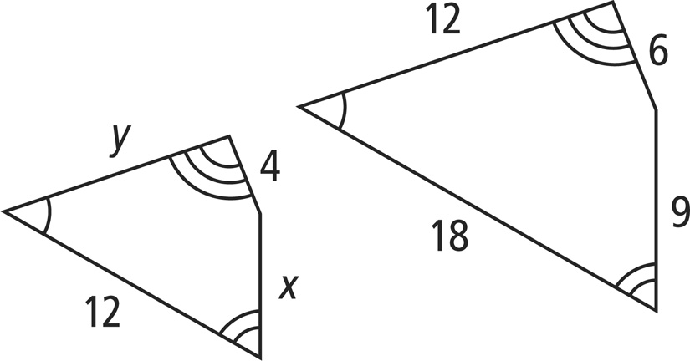15.

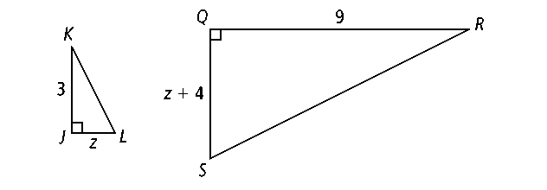16.

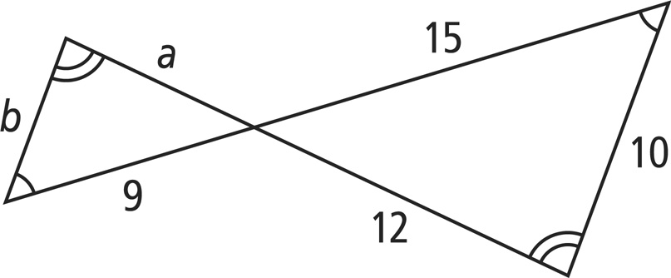17.

18. **Population Density:** A triangular field has a base that is 4 meters long and a height of 3 meters. One evening, 96 fireflies fly above the field, blinking their biolumiscent lights on and off sporadically. What is the population density of fireflies in the field?

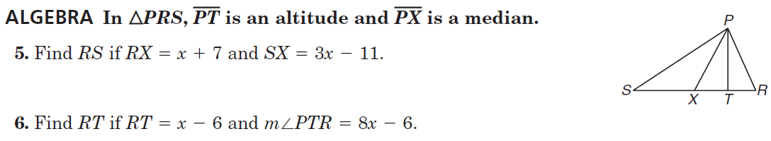

19.

20.

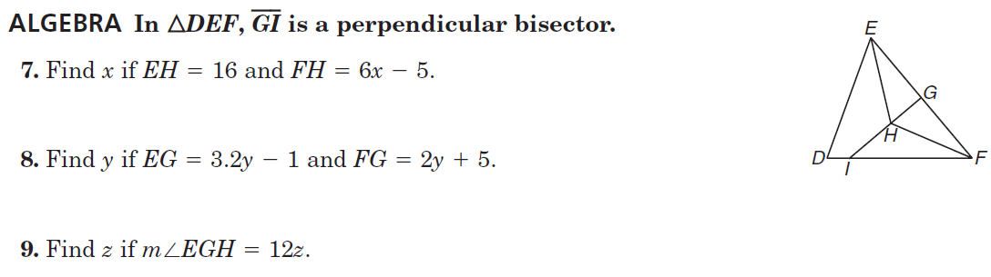

21.

22.

23.