**NC Final Review: Quiz Bowl** Name: _____________________

Math 2

Round 1: Answer each question to the best of your ability, and then turn in your group answer sheet to Ms. Russell. Remember, the answer on your answer sheet is your final answer.

|  |  |  |  |
| --- | --- | --- | --- |
| 1. | 12 less triple the difference of x and 10 is 24. Find the value of x. | 2. | Find the product of the roots of the equation |
|  |  |  |  |
| **A** | 6 | **A** | -27 |
| **B** | 8 | **B** | -36 |
| **C** | 22 | **C** | -45 |
| **D** | 18 | **D** | -26 |

|  |  |  |  |
| --- | --- | --- | --- |
| 3. | Mark has 15 coins in dimes and quarters valuing $2.10. How many dimes does he have? | 4. | A chemist plans to blend a 40% and 60% nickel alloy to obtain a 54% nickel allow. If he needs 200 pounds of the desired blend, how many pounds of 60% alloy must he blend? |
|  |  |  |  |
| **A** | 4 | **A** | 120 lbs |
| **B** | 10 | **B** | 130 lbs |
| **C** | 9 | **C** | 140 lbs |
| **D** | 11 | **D** | 150 lbs |

|  |  |  |  |
| --- | --- | --- | --- |
| 5. | 14 less than double the difference of 10 and x is at most 30. Find all the values of x and write the solutions in interval notation. | 6. | A very strong wind snaps a tree along its trunk placing the top of the tree on the ground forming a 28° with the ground. If the base of the tree is 100 feet from the fallen tip of the tree, how tall was the tree before it blew over? |
|  |  |  |  |
| **A** | [-12, ∞) |  |  |
| **B** | (-∞, -12] |  |  |
| **C** | [-14, ∞) |  |  |
| **D** | (-∞, -10] |  |  |

|  |  |  |  |
| --- | --- | --- | --- |
| 7. | A rocket is launched off a 40 foot platform with an upward velocity of 300 feet/second. What is the maximum height the rocket will achieve? | 8. | A farmer plans to use 3000 feet of fencing to create a rectangular pen for her sheep. She plans to use a river as the fourth side. What length (longest dimension) of the maximized area she could enclose? |
|  |  |  |  |
| **A** | 2002.25 feet | **A** | 1500 feet |
| **B** | 1575.74 feet | **B** | 2000 feet |
| **C** | 1324.25 feet | **C** | 1400 feet |
| **D** | 1446.25 feet | **D** | 1700 feet |

Round 2: Answer each question to the best of your ability, and then turn in your group answer sheet to Ms. Russell. Remember, the answer on your answer sheet is your final answer.

|  |  |  |  |
| --- | --- | --- | --- |
| 1. | Simplify the following: | 2. | Find the equation of the quadratic equation with the following zeros: |
|  |  |  |  |
| **A** |  | **A** |  |
| **B** |  | **B** |  |
| **C** |  | **C** |  |
| **D** |  | **D** |  |

|  |  |  |  |
| --- | --- | --- | --- |
| 3. | Write the following in radical form: | 4. | $400 is invested in an account gaining 5% APR. Find the formula for the monthly rate of growth and then identify the monthly rate. |
|  |  |  |  |
| **A** |  | **A** | 4.0% |
| **B** |  | **B** | 5.0% |
| **C** |  | **C** | 0.4% |
| **D** | None above | **D** | 0.6% |

|  |  |  |  |
| --- | --- | --- | --- |
| 5. | Jim deposited $200 into an account gaining 4% APR. How long will it take to triple his investment? | 6. | **Constructed Response**: A bacteria colony began with 10 bacteria and grew exponentially. After 5 hours it had grown to 164 bacteria. Find the hourly rate of growth. |
|  |  |  |  |
| **A** | 25 years |  |  |
| **B** | 28 years |  |  |
| **C** | 20 years |  |  |
| **D** | 16 years |  |  |

|  |  |  |  |
| --- | --- | --- | --- |
| 7. | The Camel club at Atkins is selling cookies at lunch to fundraise. Each cookie costs $0.20 to produce, and they plan to sell each cookie for $1.00. Write a function P for the profit they will make. | 8. | Find the in the given diagram. |
|  |  |  |  |
| **A** | P(x) = x + 0.20 | **A** | 41° |
| **B** | P(x) = 0.20x | **B** | 18° |
| **C** | P(x) = 0.80x | **C** | 139° |
| **D** | P(x) = x | **D** | 124° |

Round 3: Answer each question to the best of your ability, and then turn in your group answer sheet to Ms. Russell. Remember, the answer on your answer sheet is your final answer.

|  |  |  |  |
| --- | --- | --- | --- |
| 1. | If the, find. | 2. | Find the in the given diagram. |
|  |  |  |  |
| **A** | 38.5° | **A** | 30° |
| **B** | 39° | **B** | 150° |
| **C** | 7.5° | **C** | 45° |
| **D** | 39.5° | **D** | 135° |

|  |  |  |  |
| --- | --- | --- | --- |
| 3. | The perimeter of a rectangle is 40 cm. If the length is 5 more than twice the width, find the length. | 4. | The ratio of the diagonals of a kite is 2:5. If the area is 45 cm2, find the length of the longer diagonal |
|  |  |  |  |
| **A** | 5 cm | **A** | 15 cm |
| **B** | 10 cm | **B** | 13 cm |
| **C** | 15 cm | **C** | 5 cm |
| **D** | 20 cm | **D** | 3 cm |

|  |  |  |  |
| --- | --- | --- | --- |
| 5. | Find the value of x. | 6. | The number of bacteria in a culture can be modeled by the function f(x) = 30x2 – 30x + 150, where x is the temperature in Celsius. What is the approximate domain of the temperatures that will keep the culture under 350? |
|  |  |  |  |
| **A** | 5 | **A** | [-2.2°C, 4.1°C] |
| **B** | 10 | **B** | [-2.3°C, 2.4°C] |
| **C** | 15 | **C** | [-2.0°C, 3.5°C] |
| **D** | 30 | **D** | [-2.1°C, 3.1°C] |
|  |  |  |  |
| 7. | Suppose there are 5 red, 6 blue, and 9 white marbles in a bag. They are randomly selected on at a time without replacement. Find the probability of selecting a red and then a blue marble. | 8. | How many ways can the letters of FOOTBALL be arranged? |
|  |  |  |  |
| **A** | 6% | **A** | 40,320 |
| **B** | 8% | **B** | 10,080 |
| **C** | 10% | **C** | 12,820 |
| **D** | 12% | **D** | 46,086 |

Round 4: Answer each question to the best of your ability, and then turn in your group answer sheet to Ms. Russell. Remember, the answer on your answer sheet is your final answer.

|  |  |  |  |
| --- | --- | --- | --- |
| 1. | A particular lotto you choose 4 numbers from 1-20. Find the probability of selecting 2 correct numbers. | 2. | There are 30 students in the TSA club and 25 students in the Anima club. There are 10 students in both clubs. What is the probability of selecting a student in TSA given they are in the Anima club? |
|  |  |  |  |
| **A** | 15% | **A** | 1:2 |
| **B** | 18% | **B** | 2:5 |
| **C** | 8% | **C** | 5:6 |
| **D** | 5% | **D** | 3:7 |

|  |  |  |  |
| --- | --- | --- | --- |
| 3. | Find the value of x. | 4. | Suppose it takes you 30 minutes to drive to Greensboro averaging 55 mph. If you increase you average to 65 mph, how long would it take? |
|  |  |  |  |
| **A** | 6.8 | **A** | 25.2 minutes |
| **B** | 7.1 | **B** | 25.3 minutes |
| **C** | 7.3 | **C** | 25.4 minutes |
| **D** | 7.5 | **D** | 25.5 minutes |

**Constructed Response: **

5. Find  6. Find 

|  |  |  |  |
| --- | --- | --- | --- |
| 7. | The force can be used to find the force F created by a moving object given its mass m and velocity v. Suppose a 200 lb football player creates 9000 units of force. Find the players velocity. | 8. | Find the sum of the squares of the maximum values of the given quadratic functions f and g.  and g(x) is defined in the table below. |
|  |  |  |  |
| **A** | 9.5 ft/s | **A** | 18,644.8   |  |  | | --- | --- | | x | g(x) | | 1 | 79 | | 2 | 121 | | 3 | 131 | |
| **B** | 10.4 ft/s | **B** | 19,525.9 |
| **C** | 12.1 ft/s | **C** | 20,625.6 |
| **D** | 30 ft/s | **D** | 21,697.8 |

Round 5: Answer each question to the best of your ability, and then turn in your group answer sheet to Ms. Russell. Remember, the answer on your answer sheet is your final answer.

|  |  |  |  |
| --- | --- | --- | --- |
| 1. | A city map is placed on a coordinate grid. City Hall is at C(12, 10), the library is at L(9, 18), and the fire station is at F(15, 20). What is the approximate ratio of? | 2. | 40 students at Smith High play football and 60 run track. If 20 participate in both track and football, how many student athletes were counted in this scenario? |
|  |  |  |  |
| **A** | 12:13 | **A** | 100 |
| **B** | 11:15 | **B** | 80 |
| **C** | 17:9 | **C** | 60 |
| **D** | 18:11 | **D** | 50 |

|  |  |  |  |
| --- | --- | --- | --- |
| 3. | Jenny is rolling a 6 sided die 8 times. What is the probability she rolls a 3 exactly 3 times? | 4. | Cards labeled 1-10 are shuffled and randomly drawn one at a time without replacement. What is the probability of drawing a 7 and then and odd number? |
|  |  |  |  |
| **A** | 26.5% | **A** | 4.4% |
| **B** | 28.1% | **B** | 4.6% |
| **C** | 10.4% | **C** | 6.8% |
| **D** | 12% | **D** | 9.4% |

|  |  |  |  |
| --- | --- | --- | --- |
| 5. | Suppose function  is shifted 5 units left and up 2 units. What function of g models this transformation? | 6. | The zeros of the quadratic function ***g*** are {–3, 5}. Find the best equation to model ***g***. |
|  |  |  |  |
| **A** |  | **A** |  |
| **B** |  | **B** |  |
| **C** |  | **C** |  |
| **D** |  | **D** |  |
| 7. | Jim can drive to Greensboro in 15 minutes averaging 55 mph. Suppose he were to average 75 mph, find the time it would take him. Also, find the constant of variation (k). | 8. | Which property could be used to show |
|  |  |  |  |
| **A** | 11 min, k = 825 | **A** | AAS |
| **B** | 12 min, k = 820 | **B** | ASA |
| **C** | 20.5 min, k = 3.7 | **C** | SSS |
| **D** | 18.6 min, k = 3 | **D** | SAS |

Round 6: Answer each question to the best of your ability, and then turn in your group answer sheet to Ms. Russell. Remember, the answer on your answer sheet is your final answer.

|  |  |  |  |
| --- | --- | --- | --- |
| 1. | A plane intersects a right cylinder perpendicular to its bases. What type of polygon is formed by the intersection? | 2. | The value V of a car can be modeled by  where x is the number of years since the purchase. To the nearest 10th of a percent, what is the monthly rate of depreciation? |
|  |  |  |  |
| **A** | Circle | **A** | 1.1% |
| **B** | Square | **B** | 1.0% |
| **C** | Trapezoid | **C** | 1.3% |
| **D** | Rectangle | **D** | 13.0% |

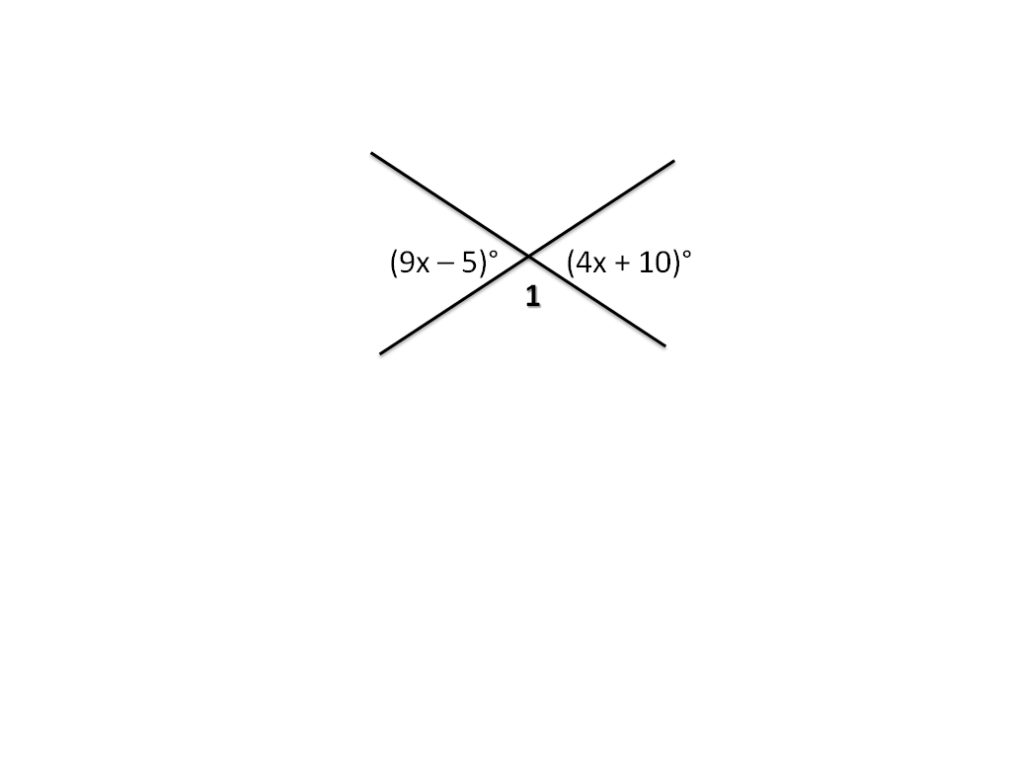

|  |  |  |  |
| --- | --- | --- | --- |
| 3. | Find the | 4. | Find the measure of the angle formed with the positive side of the x-axis and the given line. |
|  |  |  |  |
| **A** | 3° | **A** | 68.2° |
| **B** | 155° | **B** | 21.8° |
| **C** | 22° | **C** | 25.6° |
| **D** | 158° | **D** | 58.3° |

|  |  |  |  |
| --- | --- | --- | --- |
| 5. | Jim plans to use 200 feet of fencing materials to enclose a rectangular dog pen. If he uses his house as the fourth side of the rectangular pen, what is the maximum he can enclose? | 6. | Which of the following must be a factor of |
|  |  |  |  |
| **A** | 5,500 ft2 | **A** | (8x + y) |
| **B** | 5,200 ft2 | **B** | (2x – y) |
| **C** | 5,000 ft2 | **C** | (16x – 2y) |
| **D** | 4,800 ft2 | **D** | (2x + y) |

|  |  |  |  |  |
| --- | --- | --- | --- | --- |
| 7. | $600 is invested in an account gaining 5% APR. Find the formula for the monthly rate of growth and then identify the monthly rate. | 8. | A rocket is launched off a 40 foot platform with an upward velocity of 300 feet/second. What is the maximum height the rocket will achieve? |  |
|  |  |  |  |  |
| **A** | 4.0% | **A** | 2002.25 feet |  |
| **B** | 5.0% | **B** | 1575.74 feet |  |
| **C** | 0.4% | **C** | 1324.25 feet |  |
| **D** | 0.6% | **D** | 1446.25 feet |  |

Round 7: Answer each question to the best of your ability, and then turn in your group answer sheet to Ms. Russell. Remember, the answer on your answer sheet is your final answer.

1. 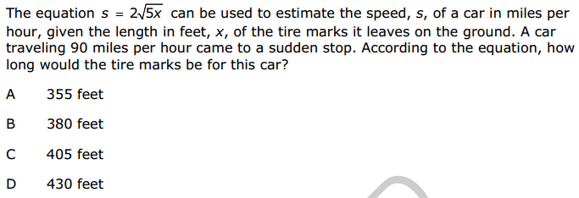
2. 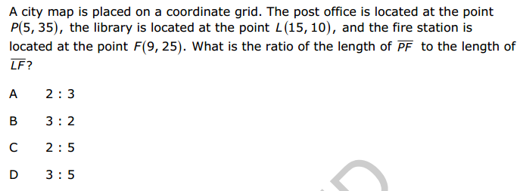
3. 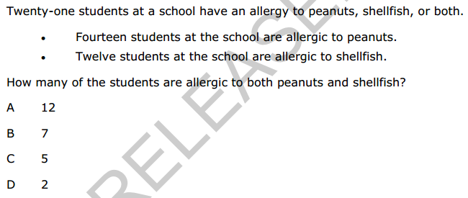
4. 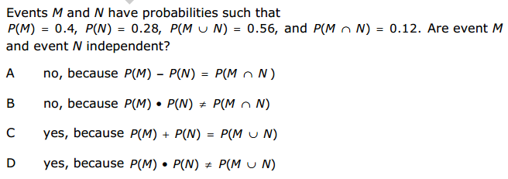
5. 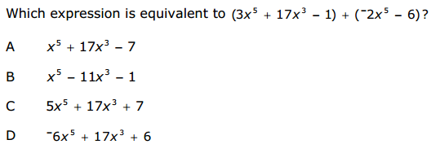
6. 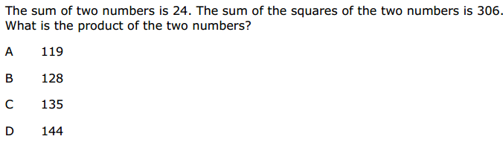
7. 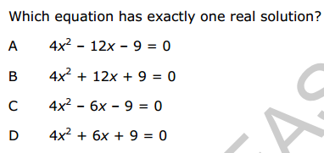
8. 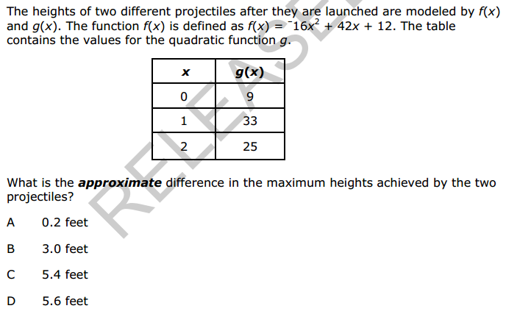

Round 8: Answer each question to the best of your ability, and then turn in your group answer sheet to Ms. Russell. Remember, the answer on your answer sheet is your final answer.

1. 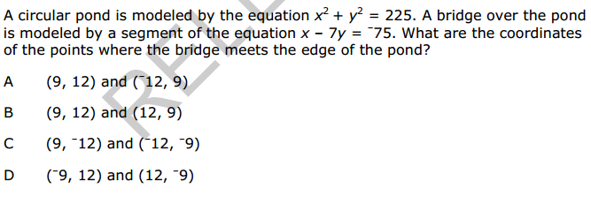
2. 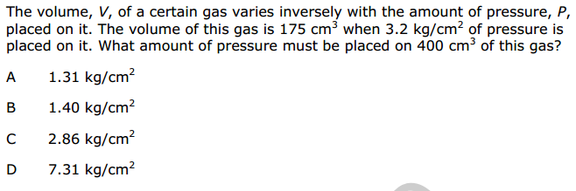
3. 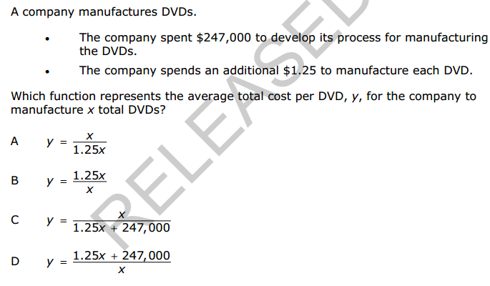
4. 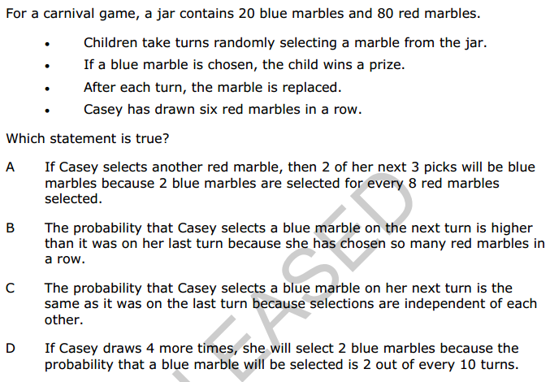
5. 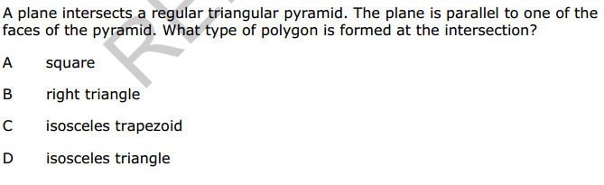
6. 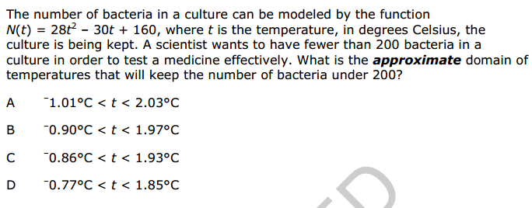
7. 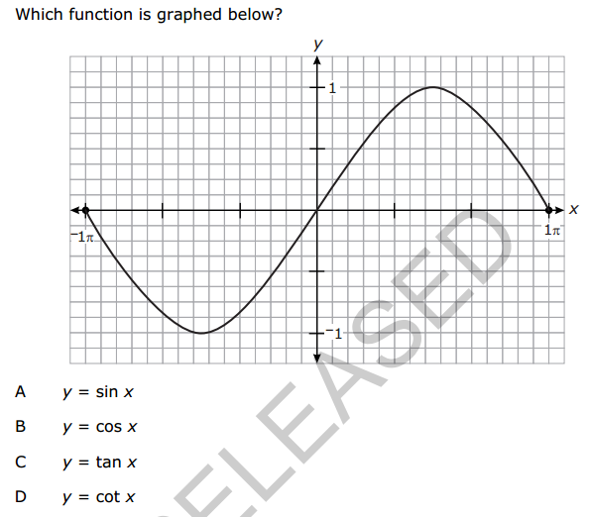
8. 

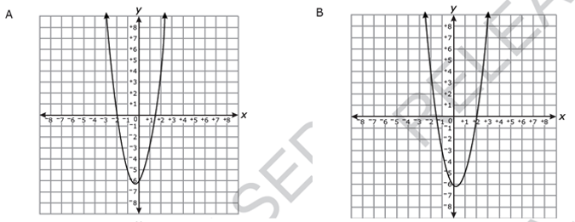

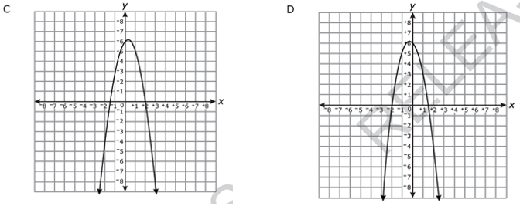

Round 9: Answer each question to the best of your ability, and then turn in your group answer sheet to Ms. Russell. Remember, the answer on your answer sheet is your final answer.

1. 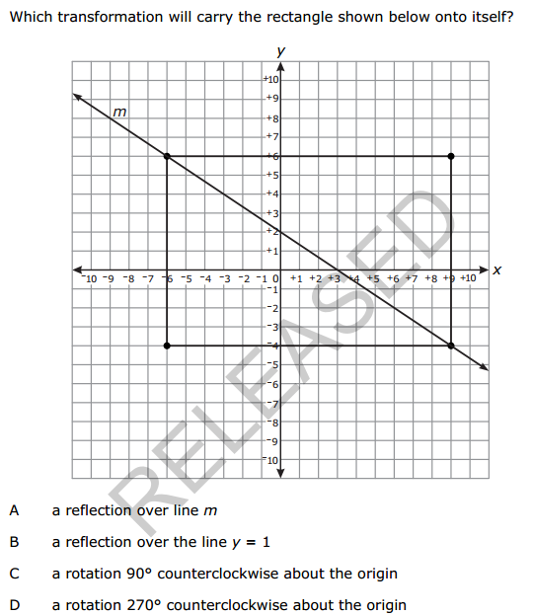

1. 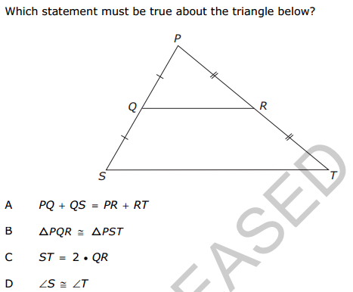
2. 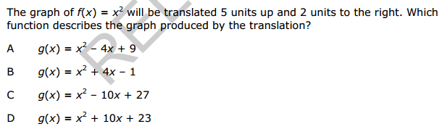
3. 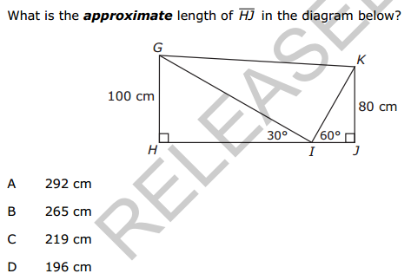
4. 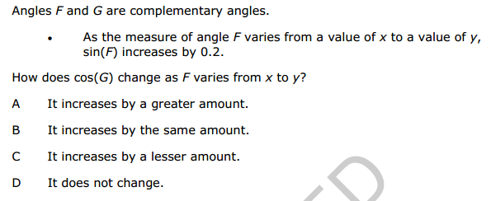
5. 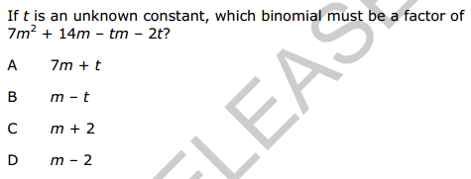
6. 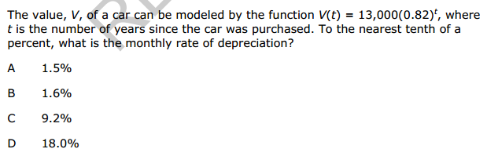

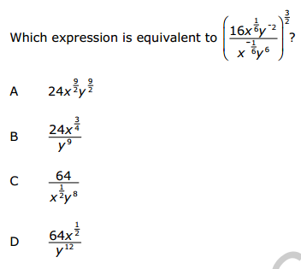

Round 10: Answer each question to the best of your ability, and then turn in your group answer sheet to Ms. Russell. Remember, the answer on your answer sheet is your final answer.

|  |  |  |  |
| --- | --- | --- | --- |
| 1. | The graph of a quadratic function opens downward and has a max at (2, 7). Which of the following could be the x-intercepts of the graph?   1. (1, 0) and (4,0) 2. (-8, 0) and (12, 0) 3. (0, 0) and (4, 0) | 2. | To the nearest degree, what is the angle measure of the angle formed with positive x-axis and the equation given below? |
|  |  |  |  |
| **A** | I only | **A** | 37° |
| **B** | II only | **B** | 39° |
| **C** | III only | **C** | 51° |
| **D** | II and III | **D** | 53° |
| **E** | None Above | **E** | 144° |

|  |  |  |  |
| --- | --- | --- | --- |
| 3. | Quadrilateral ABCD is a rhombus with sides of length 12 cm. If the, how long is? | 4. | About 40% of the US population likes Almonds. Suppose you randomly select 2 people, what is the probability that at least one of them likes almonds? |
|  |  |  |  |
| **A** | 11.73 cm | **A** | 16% |
| **B** | 12 cm | **B** | 24% |
| **C** | 12.9 cm | **C** | 36% |
| **D** | 16.97 cm | **D** | 64% |
| **E** | 20.24 cm | **E** | 80% |

|  |  |  |  |
| --- | --- | --- | --- |
| 5. | Suppose you roll a pair of dice two times. What is the probability that you roll a sum of 10, and then roll doubles on the second trial? | 6. | Suppose you roll a pair of dice and find the sum. Let event A be rolling a three on one, and event B be rolling a sum of 8. What is the P(A|B)? |
|  |  |  |  |
| **A** | 1:108 | **A** | 5:36 |
| **B** | 1:72 | **B** | 11:36 |
| **C** | 1:12 | **C** | 1:3 |
| **D** | 1:6 | **D** | 2:5 |
| **E** | 1:4 | **E** | 4:9 |

|  |  |  |  |
| --- | --- | --- | --- |
| 7. | Suppose that y is inversely proportional with a constant of variation k = 3.6. What is the value of x when y = 9? | 8. | The amount of the Brown’s water bill A is directly proportional to the number of gallons of water ***g*** used during the month with a constant of proportionality ***k***. Which of the following correctly  Expresses this relationship? |
|  |  |  |  |
| **A** | -5.4 | **A** | Ag = k |
| **B** | 0.4 | **B** | A = kg |
| **C** | 2.5 | **C** | A = k/g |
| **D** | 12.6 | **D** | A = g/k |
| **E** | 32.4 | **E** | A = g + k |

Round 11: Answer each question to the best of your ability, and then turn in your group answer sheet to Ms. Russell. Remember, the answer on your answer sheet is your final answer.

|  |  |  |  |
| --- | --- | --- | --- |
| 1. | Which of the following correctly expresses R as a function of E and I given the original function below? | 2. | The midpoint of a segment is at (-5, 2). One of the endpoints is (3, 10). What are the coordinates of the other endpoint? |
|  |  |  |  |
| **A** | R = 5EI | **A** | (-1, 6) |
| **B** | R = 5E/I | **B** | (-7, -6) |
| **C** | R = 5I/E | **C** | (-13, -6) |
| **D** | R = E/(5I) | **D** | (-13, 6) |
| **E** | R = I/(5E) | **E** | (-8, -8) |

|  |  |  |  |
| --- | --- | --- | --- |
| 3. | Which of the following is the rule for a reflection across the line ***y = x***? | 4. | The graph of is shown below. Which of the following must be true about ***K*** and ***n***? |
|  |  |  |  |
| **A** | (x, y) → (-x, y) | **A** | k > 0 and n is even |
| **B** | (x, y) → (x, - y) | **B** | k > 0 and n is odd |
| **C** | (x, y) → (-x, -y) | **C** | k < 0 and n is even |
| **D** | (x, y) → (y, x) | **D** | k < 0 and n is odd |
| **E** | (x, y) → (-y, x) | **E** | None Above |

|  |  |  |  |
| --- | --- | --- | --- |
| 5. | The cost of buying ***s*** shirts and ***h*** hats can be determined by using the equation ***C = 8s + 4h***. Suppose you have $200 to spend. Which of the following is not true? | 6. | What is the value of k the will make the line  Kx + 6y = 10 perpendicular to the line |
|  |  |  |  |
| **A** | Each shirt costs $8. | **A** | K = -9 |
| **B** | Each had costs $4 | **B** | K = -4 |
| **C** | Eight shirts and 12 hats cost $112. | **C** | K = 1.5 |
| **D** | You can buy 15 shirts and 18 hats. | **D** | K = 4 |
| **E** | You can buy 20 shirts and 15 hats. | **E** | K = 9 |

|  |  |  |  |
| --- | --- | --- | --- |
| 7. | A particular soccer player score every 1/6 shots he takes. Suppose he takes 10 shots in his next game, what is the probability he makes exactly 2 goals? | 8. | Find  for the following functions and state its domain.  and |
|  |  |  |  |
| **A** | 25% | **A** | 2x2 + 1 and [0, ∞) |
| **B** | 17% | **B** | 2x2 + 1 and [-∞, ∞) |
| **C** | 27% | **C** | 2x2 + 4x + 2 and [0, ∞) |
| **D** | 18% | **D** | 2x2 + 4x + 2 and (-∞, ∞) |
| **E** | 29% | **E** | None Above |

Round 12: Answer each question to the best of your ability, and then turn in your group answer sheet to Ms. Russell. Remember, the answer on your answer sheet is your final answer.

1. 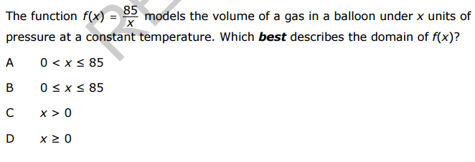
2. 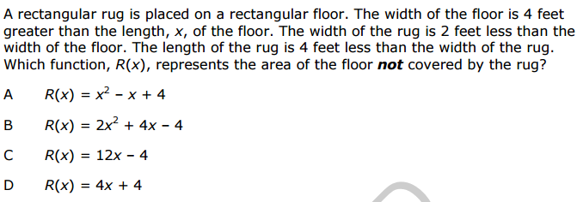
3. 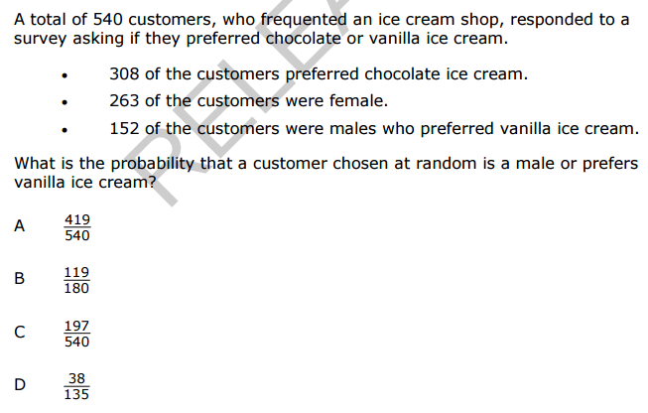
4. 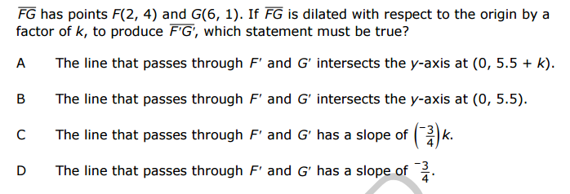
5. 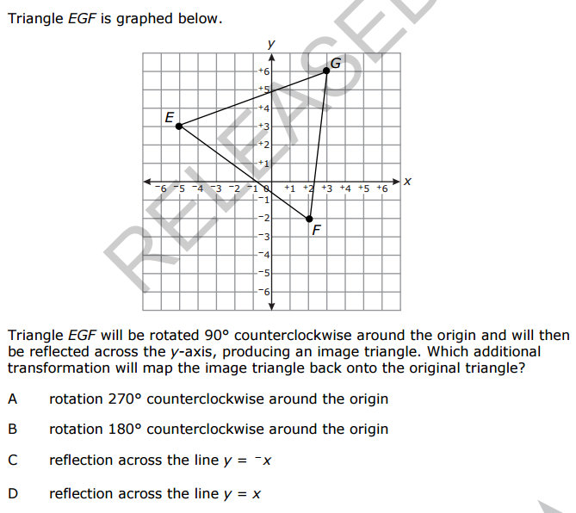
6.  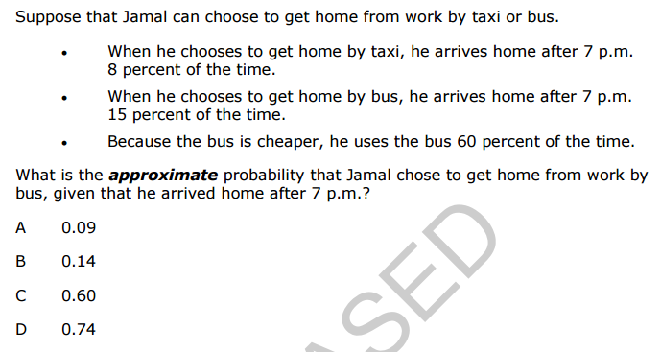
7. 