|  |
| --- |
| Homework 1.5 |

Geometry Applications C

|  |  |  |  |
| --- | --- | --- | --- |
| 1. | Simplify the following radicals:  **a)**  **b)**  **c)**  **d)** | 2. | A right isosceles triangle has legs of 10 cm. Find the length of the hypotenuse. Write answer in simplest radical form. |

|  |  |  |  |
| --- | --- | --- | --- |
| 3. | A right triangle has a hypotenuse of 12 cm and one leg with length 6 cm. Find the length of the third side. Write its length in simplest radical form. | 4. | Find the length of the diagonal of a 12 by 14 cm piece of cardboard. Write answer in simplest radical form. |

**Find the distance in simplest radical form between the given points.**

|  |  |  |  |
| --- | --- | --- | --- |
| 5. | (12, 10) and (6, 14) | 6. | (-12, 6) and (10, -6) |

|  |  |  |  |
| --- | --- | --- | --- |
| 7. | (5, -5) and (6, -6) | 8. | (0, 8) and (9, -12) |

|  |  |  |  |
| --- | --- | --- | --- |
| 9. | Jim lives 4 miles east and 2 miles north of the bus station. If Marcus lives 7 miles west and 3 miles south of the same station, how far apart do the two guys live? (round to the 10th) | 10. | Mary lives 4 blocks north and two blocks west of her school. Her friend Julie lives 3 blocks south and 2 blocks east of the school. If each block in their city is an 1/8 mile long, how far to the girls live apart? (round to the 10th) |

**Review**

11. Find the value of x and the measure of each 12. Write the absolute value inequality graphed below.

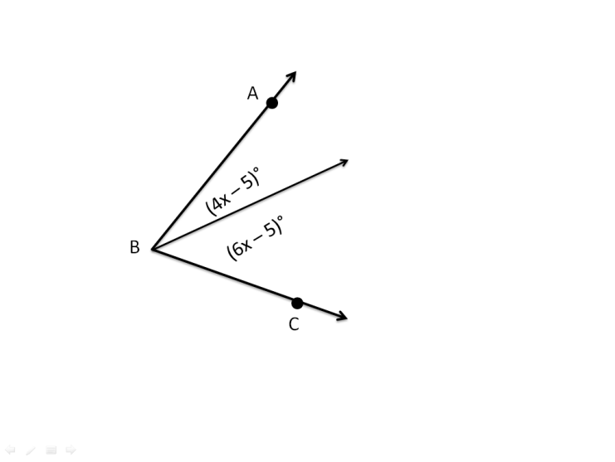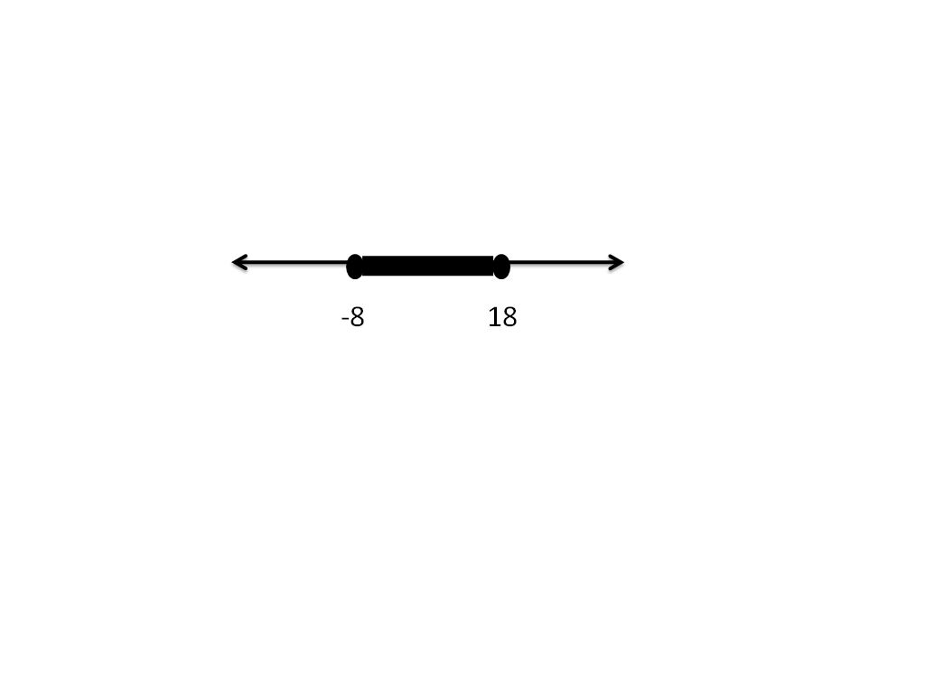 angle if .