Homework 5.1: Multiplying & Dividing Rationals Name: ______________________
Math 3

Directions: Simplify each rational expression. State any restrictions on the variables.

- 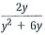

- 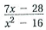
- 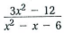
- 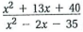

Directions: Multiply. State any restrictions on the variables.

- 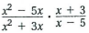

- 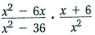
- 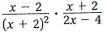

- 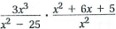

- 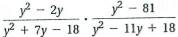

Directions: Divide. State any restrictions on the variables.

- 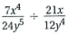
- 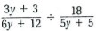

- 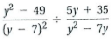
- 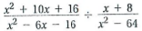

- 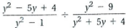
- 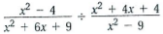

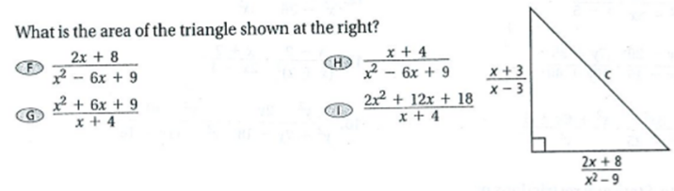

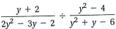
- What is the quotient expressed in simplest form? State any restrictions on the variable.

