Final Exam Review: Study Guide Name:_________________________
AFM

- For the following arithmetic sequence, find the 18th term of 1.4, 1.9, 2.4

- Find the three arithmetic means between 2 and 5.

- Find the sum of the first 35 terms of the arithmetic sequence when $a_{1}=5 and d=4$

- Find the sum of the arithmetic series in which $a_{1}=5 and a_{34}=71$

- Evaluate: $\sum_{n=1}^{4}{(2n-7)}$

- Find the sixth term of the geometric sequence: $1,\frac{3}{4},\frac{9}{16},$

- Find the sixth term of the geometric sequence if $a_{1}=48 and r= -2$

- Find the 8th term of the geometric sequence when $a_{1}=9 and r= -2$

- Find the four geometric means between 128 and 4.

- Find the sum of the first five terms of the geometric series: $\frac{1}{3}+2+12+…$

- Find the sum of the infinite geometric series, if it exists. $\sum_{n=1}^{∞}{2k}$

- Find the sum of the infinite geometric series, if it exists: $20-2+\frac{1}{5}-…$

- Find the six trigonometric functions for the given triangle:
$$θ$$
14
16
21

- Find all the missing angle and side measures for the right triangle:
B

40
16

C
A

- A ramp in a park is 48 feet long and rises 6 feet. Estimate the angle to the nearest tenth that the ramp makes with the ground.

- Given triangle ABC with a = 14, A = 40$°$, and B = 28$°$, what is the measure of c?

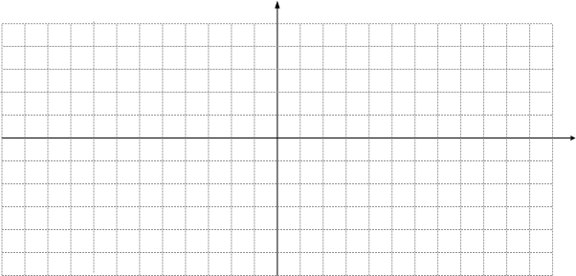

- Graph $y=2\sin{θ-4}$

- State the amplitude, period, vertical shift, and horizontal shift for: $y=6\sin\left(4θ\right)+5$

For questions 19 – 21, use the following information: On a normal curve, the mean on the Algebra II Final is 54, with a standard deviation of 11.8

- What percent of students are within 2 standard deviations of the mean?

- If 120 students took the test, how many scored higher than 65.8?

- What percent scored lower than 54?

- Graph the piecewise function: $y= \left|2x\right|$

- A 9-member committee is selecting a president, vice-president, secretary, and treasurer from the committee. No person can serve in two positions. In how many ways can the four positions be filled?

- Teddy is buying a sports car. He can buy red or black, convertible or hard-top, straight drive or automatic. How many possible models does he have to choose from?

- How many possible ways can you choose 3 library books to check out from 8?

- How many ways can you arrange 8 candles on the top of a birthday cake?

- How many ways are there to arrange the letters in “Trigonometry”?

- How many ways can Mrs. Smith’s preschool class of 12 students line-up to go outside and play?

- How many groups of 5 students can be chosen from 25?

- How many ways can you choose a group of 5 men and 7 women from 12 men and 13 women?

- Suppose you select 3 letters from the word CLEMSON. What is the probability of selecting 2 vowels at the same time?

- A bag contains 8 orange marbles and 5 purple marbles. If a marble is chosen at a random, what is the probability that it is not purple?

- Billy breaks his piggy bank and finds 5 pennies, 8 nickels, and 9 dimes. What is the probability that he will selection 1 dime and 1 nickel at the same time?

- What is the probability he will select 2 pennies at the same time?

- A die is thrown twice. What is the probability that a 4 is thrown followed by a 6?

For questions 36 – 38, 12 playing cards (3 Aces, 4 Kings, 2 Queens, and 3 Jacks) are placed on the table face down. If four cards are selected at random, find the probability that:

- You select Ace, Jack, King, King, without replacement.

- You select a Queen, King, Jack, Ace, with replacement.

- You select Queen, Queen, Ace, any card other than Ace, without replacement.

- Find the value of .

a) 15 b) 2 c) 24 d) 360

- Find the standard deviation for the given data: $5, 6, 8, 11, 10$

a) 3.28 b) 1. 28 c) 2.28 d) 4. 28

- Solve: $\frac{x+9}{x+8}= \frac{x-7}{x-6}$

a) x = -1 b) x = 0 c) x = 2 d) x = -3

- Evaluate: $\log_{9}729$

a) 3 b) 5 c) 4 d) 2

- Evaluate: $\log{94}$

a) 9.4 b) 1.97 c) .51 d) 3.95

- Solve $e^{4x}=5.7$ for x to four decimal places.

a) -0.4030 b) 0.4351 c) 0.7559 d) -0.7559

- $\log_{9}\left(x^{2}+7\right)= \log_{9}(43)$

a) $± 36$ b) $±6$ c) $±6.56$ d) $±5$

- $\ln\left(-2y+5\right)-\ln\left(y+4\right)=\ln\left(-11y-2\right)$

a) (-3.68, - .32) b) infinite solutions c) (3.68, .32) d) no solution

- Radioactive Iodine-129 decays over time into stable Xenon-129. The percent of I-129 remaining in several mineral samples can be used to calculate the radioactive half-life of I-129, based on the ages of the mineral samples determined by other “dating” techniques. The following table shows data on the percent of I-129 remaining in minerals of different ages.
Age (billions of years) | 2.0 | 3.5 | 4.2 | 4.3
Percent of original I-129 | 74 | 59 | 53 | 52

- Find the regression equation for the percent of I-129 remaining as a function of time x.
- Write the regression equation in terms of base e.
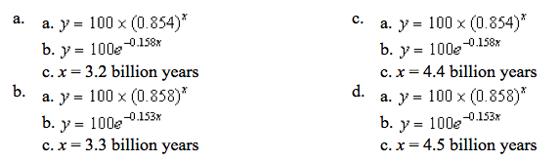
c. Use the equation from part b to estimate the half-life of Iodine-129.

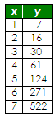
- Find an exponential function to model the data.
- $f\left(x\right)=116.4-42.8 \ln{x}$
- $f\left(x\right)= 2.204 {(3.56)}^{x}$
- $f\left(x\right)= 3.56{\left(2.04\right)}^{x}$
- $f\left(x\right)= -42.8+116.4\ln{x}$

- Find the best fit regression model for the data according to the given model.

x | y
1 | 50
2 | 140
3 | 260
4 | 400
5 | 560
6 | 750
7 | 925
8 | 1130
- ${49.79x}^{1.50}$
- ${5.48x}^{.32}$
- $156.13x -175.71$
- $1.5x+3.91$

- As automobiles age, the average miles traveled per gallon decreases. Determine the regression equation that best models the data.
- Power
- Logarithmic
- Quadratic
- Exponential
Age (years) | MPG
1 | 35
3 | 34
5 | 33
7 | 31
9 | 28
11 | 26
13 | 23
15 | 18

- What is the explicit form of the equation: $a_{1}= a_{n-1}+2\left(n-1\right) ; a_{1}=1$
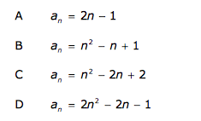

- Which function has an amplitude that is twice the size and a period that is three times the size of the function $y=3\cos\left(\frac{x}{4}-1\right)+2$

