Math 1 EOC Gridded Response Practice

This is an example of a grid on your answer sheet used to record responses to the gridded response items. You may want to look at this example grid when you write down your answer to the gridded response items so you know what format to use.

Only 1, 2, 3, 4, 5, 6, 7, 8, 9, ., -, and / are allowed in your answer.

Answers that are mixed numbers must be written down as an improper fraction or decimal.

#1 #2 #3 #4 #5 #6 #7
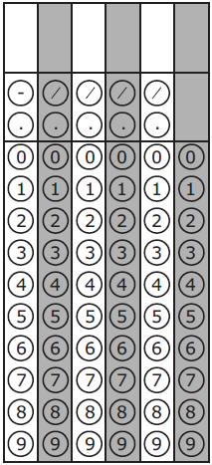

#8 #9 #10 #11 #12 #13 #14

#15 #16 #17 #18 #19 #20 #21

